Data Analytics Internship
A Project Report submitted to the
GLOBAL NEXT CONSULTING INDIA PVT LTD,
Gurugram
For the Partial Fulfilment of the Required credits for the internship of
Data Analytics
By
Prakhar Khandelwal
Under the Supervision of
Dr. Anuradha Gupta
(Project Director)

GLOBAL NEXT CONSULTING INDIA PVT LTD



CANDIDATE’S DECLARATION
I hereby declare that the work presented in this report, titled “Data Analyst Internship (GNCIPL)”, is the result of my own effort and learning during my internship at GNCIPL, carried out under the guidance of Ms. Anuradha Gupta from 25 October 2025 to 15 December 2025.
This report reflects my genuine work and experiences throughout the internship and does not include any fabricated data, information, or content taken from other sources without proper acknowledgment. I have maintained honesty, integrity, and professionalism in completing this work and confirm that it has not been submitted to any other organization or institution for any purpose.

Prakhar Khandelwal

CERTIFICATE

This is to certify that Mr. Prakhar Khandelwal has successfully completed his Data Analytics Internship at Global Next Consulting India Pvt. Ltd. (GNCIPL), Gurugram, during the period 25 October 2025 to 15 December 2025.
During his internship, he worked on the project titled “Data Analyst Internship Report” under the guidance of Ms. Anuradha Gupta. The report and the work carried out reflect his dedication, learning, and contribution to the assigned tasks and objectives.
We confirm that this work is original and has not been submitted to any other organization for any academic or professional certification.
We wish him continued success in all his future endeavours.

Ms. Anuradha Gupta
Program Director
GNCIPL
Noida, UP

ACKNOWLEDGEMENT

I would like to take this opportunity to express my heartfelt gratitude to everyone who supported me during my internship and contributed to the successful completion of this report.
First and foremost, I would like to extend my sincere thanks to Ms. Anuradha Gupta for her invaluable guidance, constant encouragement, and thoughtful feedback throughout the internship. Her insights and mentorship were instrumental in helping me learn and complete this project successfully.
I am also deeply grateful to the entire team at Global Next Consulting India Pvt. Ltd. for their support, cooperation, and for providing me with the resources and a collaborative environment to apply and enhance my skills.
Lastly, I would like to thank my peers and colleagues for their helpful discussions and encouragement during this journey. Their support made this experience both productive and enjoyable.

Prakhar Khandelwal
Global Next Consulting India Pvt. Ltd.
Gurgaon

ABSTRACT
This report summarizes my six-week internship as a Data Analyst Intern at Global Next Consulting India Pvt. Ltd., Noida. The internship was structured into six minor projects and one major project, aimed at developing practical skills in data handling, statistical analysis, and visualization.
The internship projects as a whole strengthened my technical skills in Python, Excel, and data visualization, while also improving my analytical thinking and problem-solving approach. The work highlights how data analytics can uncover meaningful insights to support informed decision-making in domains such as public health, environment, and business.

INDEX

Candidate’s Declaration
Certificate
Acknowledgement
Abstract
Chapter 1: Introduction
1.1 Company Profile
1.2 Objectives of Internship

Chapter 2: Methodology
2.1 Tools and Techniques used
2.2 Data Sources and Collection
2.3 Data cleaning and Preprocessing
2.4 Visualisation Techniques

Chapter 3: Project Work
3.1 Week 1 Project: Air Quality Dashboard- Delhi in Excel
3.2 Week 2 Project: Environmental Sensor Data Monitoring(Water Quality) using SQL & Python
3.3 Week 3 Project: Environmental Sensor Data Monitoring(Water Quality) using R.
3.4 Week 4 Project: Fitness Tracker Dashboard
3.5 Week 5 Project: Automated Traffic Pattern Analysis Using AI
3.6 Major Project: Poverty & Unemployement Correlation Analysis

Chapter 4: Results and Discussions
4.1 Insights from Weekly Projects
4.2 Skills Gained

Chapter 5: Conclusion
5.1 Overall Learning Outcomes
5.2 Applications of Work

Internship Certificate
Summary
References

Chapter 1- Introduction

1.1 Company’s Profile
Global Next Consulting India Private Limited (GNCIPL), headquartered in Greater Noida, Uttar Pradesh, is a cybersecurity-focused consulting firm dedicated to helping organizations protect their digital assets, data, and reputation. As threats evolve in today’s digital world, GNCIPL offers proactive, customized solutions rather than reactive fixes. The company serves clients in diverse sectors including finance, healthcare, manufacturing, and technology, providing services like threat detection, risk assessment, incident response, compliance consulting, and 24/7 monitoring. GNCIPL’s core values are integrity, innovation, customer-centricity, excellence, and collaboration—ensuring that technical solutions align with clients’ specific needs and long-term goals.
Contact Details
Location- B5,402 P4 PHi2, CGEWHO TOWER, GREATER NOIDA 201310
Contact Numbers- 0120-4001768, +91-9315504902. +91-7666141260 Mail- hr@gncipl.com

1.2 Objectives of Internship
During my six-week internship at GNCIPL as a Data Analyst Intern, the main objectives were:
- To gain hands-on experience in data analytics tools and techniques, especially using Python (Jupyter Notebook) and Microsoft Excel.
- To work on real-world datasets and deliver meaningful insights, visualizations, and dashboard reports.
- To learn data preprocessing, cleaning, transformation, and applying formulas and classification logic.
- To enhance analytical thinking, effective communication, and presentation skills through weekly minor projects and a major end project.

Chapter 2 - Project Work

2.1 Air Quality Dashboard - Delhi Analysis Report (Jan 2021 - Jan 2023) (Week 1)

2.1.1. Introduction
This report presents the findings from a data analysis project on the Air Quality in Delhi. The primary objective of this research is to analyse the trend and composition of key air pollutants (PM 2.5, PM 10, O3, NO2, etc.) in Delhi over a two-year period (Jan 2021 to Jan 2023). The analysis seeks to identify the most polluted months and verify the hypothesis that air quality significantly deteriorates during the winter months (Oct-Feb) due to high PM 2.5 concentrations

2.1.2 Objectives
The main objectives of this analysis are:
- To clean and prepare the dataset for analysis.
- To identify most populated months and composition of different pollutants.
- To explore patterns and trends using various data visualizations charts and dashboard.

2.1.3 Dataset
The dataset for this project was obtained from Publicly available Air Quality dataset for Delhi sourced from Kaggle (Jan 2021 - Jan 2023).

2.1.4 Methodology
The project was conducted using Microsoft Excel. The following steps were performed for data processing, analysis, and visualization:
- Data Cleaning:
1. Removed duplicate timestamp entries.
2. Fixed date/time columns to ensure correct formatting (DATE(), TIME()).
3. Handled blank values by using conditional checks.
- Data Preparation Steps:
- Data Loading: Data imported into an Excel sheet in .csv format.
- Feature Engineering: New columns, Time and Month, were created to provide a more descriptive view of the pollutant trend.
- Exploratory Data Analysis: The dataset was analysed using Conditional Formatting to aggregate hourly data into average monthly figures for visualization of different pollutants.

2.1.5 Analysis and Results
Core Analysis (Formulas, PivotTables, Logic)

1. Monthly Trend Pivot: Summarized the Average of PM 2.5 for each month-year combination to show the cyclical pollution pattern.
2. Pollutant Composition Pivot: Calculated the total average concentration for each major pollutant over the entire 2-year period to determine the relative contribution by percentage.
3. Top Polluting Months Pivot: Ranked months by the highest Average of PM 2.5 to identify the most severe pollution events.
4. Hourly PM 2.5 Trend (Line Chart): Shows the average PM 2.5 concentration across a 24-hour cycle.
5. Hourly Pollutant Comparison (Column Chart): Compares the hourly trend of PM 2.5, PM 10, and NO2.
Key Findings:

- Dominant Pollutant is PM 2.5: PM 2.5 accounts for a staggering 78.72% of the total measured pollutant mass. This confirms the hypothesis that it is the primary driver of air quality issues in Delhi. The next highest is PM 10 at only 8.05%.
- Clear Seasonal Pattern: The PM 2.5 Trend line graph shows a consistent and severe spike in pollution levels towards the end of the year, peaking in November and December for both 2021 and 2022. Pollution levels are lowest in the monsoon/summer months (June - August).
- Most Polluted Months are Winter Months: The "Most Polluted Month" chart confirms the worst pollution occurs during the winter-stubble burning period:
  - Feb-21 (491.83)
  - Dec-21 (438.20)
  - Nov-21 (427.81)
- Deterioration in Late 2022: The 'PM 2.5 Trend' indicates the highest peak of the analyzed period occurred in December 2022 (438.20), showing that the severity of the winter pollution issue has persisted.
- Morning Rush Hour Peak: The overall PM 2.5 concentration starts high in the early morning, slightly dips, and then shows a pronounced increase around 03:00-04:00 (3 AM - 4 AM).
- Severe Evening Peak: The pollution is worst during the evening hours. PM 2.5 and PM 10 levels rise sharply from 15:00 (3 PM) and peak significantly between 17:00 (5 PM) and 19:00 (7 PM), coinciding with peak traffic and atmospheric cooling (inversion layer formation).
- PM 10 levels consistently reach their highest point around 17:00 (5 PM).
- PM 10 is Consistently Higher: Across all hours of the day, the average concentration of PM 10 is higher than PM 2.5 (as expected, since PM 10 includes PM 2.5). Both pollutants follow a very similar pattern, peaking sharply in the late afternoon.
- NO2 Pattern Differs: Nitrogen Dioxide (NO2), primarily associated with traffic emissions, follows the same general evening spike but at much lower concentrations compared to particulate matter.

Visualizations and Insights:

- Line Chart (PM 2.5 Trend): The chart shows monthly changes in Delhi’s Air Quality Index (AQI) from January 2021 to January 2023. Air quality becomes worse during the winter months, often reaching “very poor” or “severe” levels due to cold weather, low wind speed, and emissions from vehicles and crop burning. In contrast, the summer and monsoon seasons show improved air quality as rainfall and higher temperatures help disperse pollutants. This trend highlights the combined effect of weather conditions and human activities on Delhi’s air quality throughout the year.

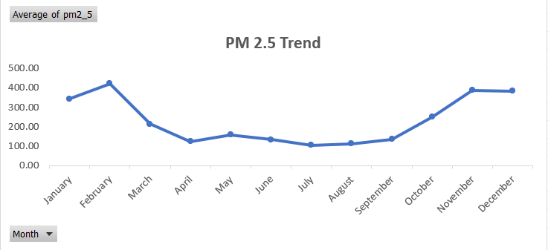

- Pie Chart (Pollutant Composition): The pie chart represents PM 2.5 accounts for a staggering 78.72% of the total measured pollutant mass. This confirms the hypothesis that it is the primary driver of air quality issues in Delhi. The next highest is PM 10 at only 8.05%.
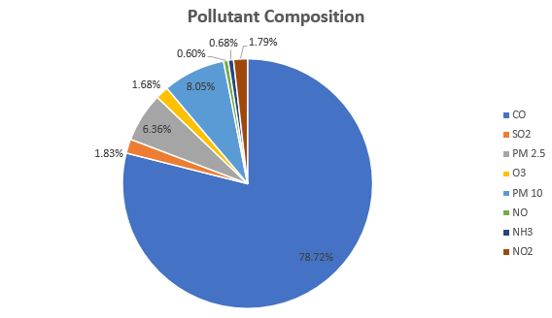
- Clustered Column Chart (Monthly Pollution Levels): The chart shows the monthly variation in Delhi’s Air Quality Index (AQI) from January 2021 to January 2023. Air quality worsens notably during winter, reaching “very poor” or “severe” levels due to low temperatures, weak winds, and emissions from vehicles and crop burning. In contrast, summer and monsoon months record cleaner air as rainfall and higher temperatures help disperse pollutants. Overall, the chart highlights how both weather conditions and human activities jointly influence Delhi’s air quality throughout the year.
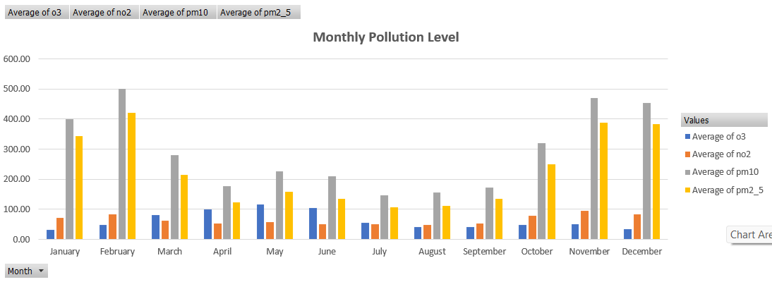

- Horizontal Bar Chart (Top Polluted Months) : The analysis shows that February 2021 recorded the highest pollution levels, with an average PM2.5 concentration of around 492 µg/m³, followed by December and November 2021. The consistently high levels during the winter months (November to February) indicate a clear seasonal pattern. This rise in pollution is likely due to factors such as low wind speed, temperature inversion, and increased combustion activities like heating and crop residue burning.

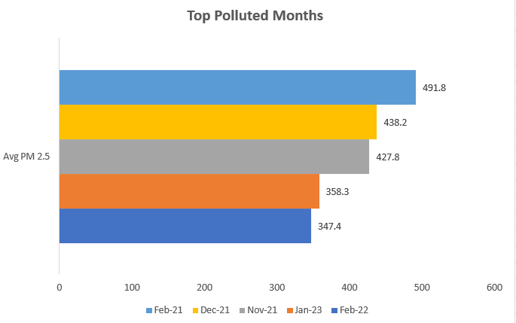

- Line Chart (Hourly Pollution Pattern) : The chart shows a clear daily pollution cycle in Delhi, with the lowest levels between 7 AM and 10 AM due to improved air dispersion after sunrise. Pollution gradually increases from noon and peaks between 4 PM and 6 PM, likely driven by evening traffic and stagnant air. A smaller rise around 3–4 AM suggests pollutants get trapped near the surface as temperatures drop. Overall, the pattern reflects how human activity and temperature changes influence hourly pollution levels.
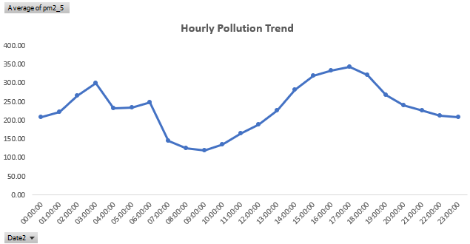
- Clustered Column Chart (Hourly Comparison of PM2.5 vs PM10): The chart shows that both PM2.5 and PM10 follow similar hourly patterns, indicating a strong correlation between them. PM10 levels are consistently higher than PM2.5, with the gap widening during peak hours (3 PM–6 PM), likely due to increased dust and coarse particles from human and industrial activity. The lowest concentrations are seen in the morning hours (7 AM–10 AM), while the highest levels occur around 5 PM, suggesting that traffic congestion and industrial emissions significantly contribute to pollution during late afternoon and evening hours.
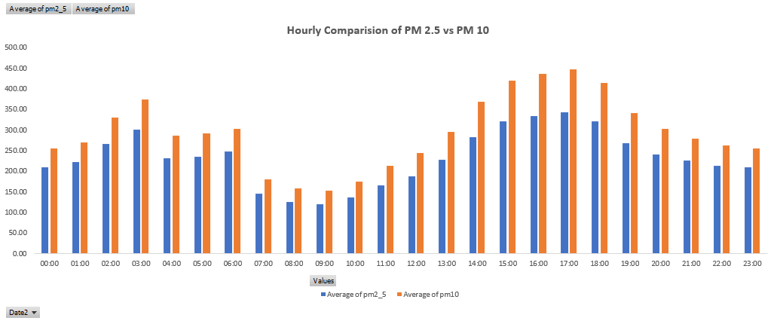

2.1.6 Conclusion

Based on the comprehensive analysis of the Delhi Air Quality Index (AQI) data spanning two years (Jan 2021 - Jan 2023), the following conclusions are drawn, integrating the findings from the monthly trends, pollutant composition, and critical hourly patterns:

1. Validation of Seasonal Hypothesis

The initial hypothesis—that Delhi's air quality significantly deteriorates during winter months—is strongly validated. The monthly trend analysis clearly demonstrates a severe and cyclical spike in pollutant concentrations, primarily PM 2.5, occurring from October through February. The highest average pollution levels are consistently recorded in the winter/post-monsoon months (e.g., Feb-21, Nov-21, Dec-22), corresponding to periods of stubble burning, increased heating needs, and adverse meteorological conditions (low wind speed and temperature inversions).

2. PM 2.5 as the Dominant Health Risk

The pollutant composition analysis establishes PM 2.5 as the overwhelming dominant air quality driver, accounting for nearly 79% of the total measured mass. This confirms that mitigation strategies must remain laser-focused on controlling the primary sources of fine particulate matter, which poses the greatest threat to public health.

3. Critical Hourly Peaks Reveal Actionable Targets

The introduction of the hourly analysis provides crucial detail for targeted policy intervention:

Late Evening Peak: The most severe pollution occurs in the evening, peaking sharply between 17:00 and 19:00 (5 PM to 7 PM). This peak is likely driven by the combination of high vehicular and traffic activity coinciding with atmospheric boundary layer collapse (the formation of a temperature inversion layer) which traps pollutants close to the ground.

Early Morning Concentration: A secondary high concentration is observed around 03:00–04:00 (3 AM – 4 AM), which may relate to nocturnal goods transport, localized waste burning, or sustained low wind speeds overnight.

2.2 Environmental Sensor Data Monitoring (Water Quality) (Week 2)

2.2.1 Introduction

The quality of water resources is a crucial indicator of environmental health and public safety. Monitoring and analysing water parameters enable early detection of pollution, ensuring sustainable water management.
This project focuses on collecting, cleaning, and analysing water quality sensor data from various monitoring stations across India. The dataset includes parameters such as temperature, dissolved oxygen (DO), pH, biochemical oxygen demand (BOD), conductivity, and coliform levels.
The end goal is to assess the Water Quality Index (WQI) and identify patterns, anomalies, and critical water quality trends through SQL-based analysis and Excel dashboards.

2.2.2 Objectives

To preprocess and clean raw water quality data collected from sensors across India.

To calculate the Water Quality Index (WQI) based on multiple physicochemical and biological parameters.

To identify anomalies and patterns in the dataset.

To visualize key insights through an interactive Excel dashboard.

To store and analyse the cleaned dataset using MySQL for advanced querying and reporting.

2.2.3 Methodology

a) Dataset Preparation
Dataset source: Kaggle – “Water Quality in India” Attributes included:
STN Code, Monitoring Location, Year, Type Water Body, State Name, Temperature, Dissolved Oxygen, pH, Conductivity, BOD, Nitrate, Coliforms

b) Data Cleaning and Preprocessing
- Removed duplicates and missing or inconsistent values.

Combined min/max readings (e.g., Temperature Min & Temperature Max) into an average value (avg_temperature).

Standardized column names and formatted text data (locations, states, etc.).

Calculated derived features like:

avg_dissolved

avg_bod_mgl

avg_ph

avg_conductivity_mhocm

avg_nitraten_mgl

c) WQI(Water Quality Index) Calculation
• Each parameter was assigned a sub-index (e.g., wq_score_ph, wq_score_do, wq_score_bod, etc.) based on standard water quality ranges from CPCB guidelines.
The overall WQI was calculated as an average of these scores, categorized as:
- 0–25 → Excellent
- 26–50 → Good
- 51–75 → Moderate

d) SQL Integration
The cleaned dataset was imported into MySQL for analysis. Key queries included:
1. Count monitoring stations per state
SELECT `State Name`, COUNT(DISTINCT `STN Code`) AS Station_Count
FROM water_quality
GROUP BY `State Name`;

2. Average WQI by State
SELECT `State Name`, ROUND(AVG(WQI),2) AS Avg_WQI
FROM water_quality
GROUP BY `State Name`
ORDER BY Avg_WQI DESC;

3. Top 10 Most Polluted Locations
SELECT `Monitoring Location`, WQI
FROM water_quality
ORDER BY WQI DESC
LIMIT 10;
4. Yearly trend of WQI
SELECT `Year`, ROUND(AVG(WQI),2) AS Avg_WQI
FROM water_quality
GROUP BY `Year`;

5. Category distribution
SELECT WQI_Category, COUNT(*) AS Count
FROM water_quality
GROUP BY WQI_Category;

e) Dashboard Design (Excel)
An Excel dashboard was created using Pivot Tables and Charts to visualize insights.
Charts included:
- Distribution of Water Bodies – Pie Chart
- Average WQI by Water Body Type – Column Chart
- Average WQI by State – Horizontal Bar Chart
- Top 10 Locations by WQI (Worst to Best) – Bar Chart
- Distribution of WQI Categories – Donut Chart
- Yearly Trend of WQI – Line Chart
- KPI Cards – Average WQI and Count of Monitoring Stations

2.2.4 Results and Insights

a) Distribution of Water Bodies (Pie Chart)
- The majority of monitored water bodies are Rivers (31.79%), followed by Lakes (18.04%) and Ponds (13.37%).
- Creeks and Drains have very few monitoring points (<1%), indicating limited data or low focus on these sources.
- The water quality monitoring is more concentrated in rivers and lakes, reflecting their higher environmental and social importance.

b) Average WQI by Type of Water Body (Bar Chart)

Ponds and Rivers show higher WQI values, indicating comparatively better water quality.

Drains and Creeks exhibit lower WQI, suggesting higher pollution levels.

Open and flowing water bodies (like rivers) tend to self-purify, while stagnant or industrial drains accumulate pollutants.

c) Average WQI by State (Horizontal Bar Chart)

Uttarakhand, Rajasthan, and Telangana have the highest average WQI, indicating cleaner water quality.

Andhra Pradesh, Delhi, and Gujarat show relatively lower WQI, requiring attention.
Interpretation:

Mountainous regions (like Uttarakhand) maintain natural purity, while urban/industrial states face higher contamination risks.

d) Distribution of WQI Categories (Pie Chart)
- 75% of water bodies fall under the Excellent category.
- 19% are Moderate, and only 6% are Good.
- Overall water quality is commendable; however, a notable portion still needs improvement to shift from “Moderate” to “Good/Excellent”.
e) Yearly Trend of WQI (Line Chart)
- WQI rose sharply in 2023 (17493.2 total) compared to 2021 and 2022 (around 5900–5970).
- Indicates a significant improvement in water quality or expanded monitoring coverage post-2022.
- Could also reflect better management or stricter environmental measures.
f) Comparison of Major Pollutants by Water Body Type (Bar Chart)
- Biochemical Oxygen Demand (BOD) and Nitrate levels vary across water body types.
- Marine and Canal waters show relatively balanced pollutant levels, while Drains have higher conductivity and BOD.
- Stagnant or semi-urban channels accumulate industrial and organic pollutants, affecting dissolved oxygen balance.
g) Top 10 Sources by WQI (Horizontal Bar Chart – Worst to Best)
- Guntathippa with Rives Canal (71.3) has the best WQI, while Kampilpur (58.7) and Neer Dam (59.8) rank lower.
- Narrow range (58–71) suggests moderate variation among locations.
- Even top-performing sources need sustained monitoring to maintain WQI above 70 for optimal water safety.
h) KPI Cards
- Average WQI: 14.87
- Total Monitoring Stations: 194
- Data collection is widespread but the average WQI value suggests mixed results when considering scale normalization.

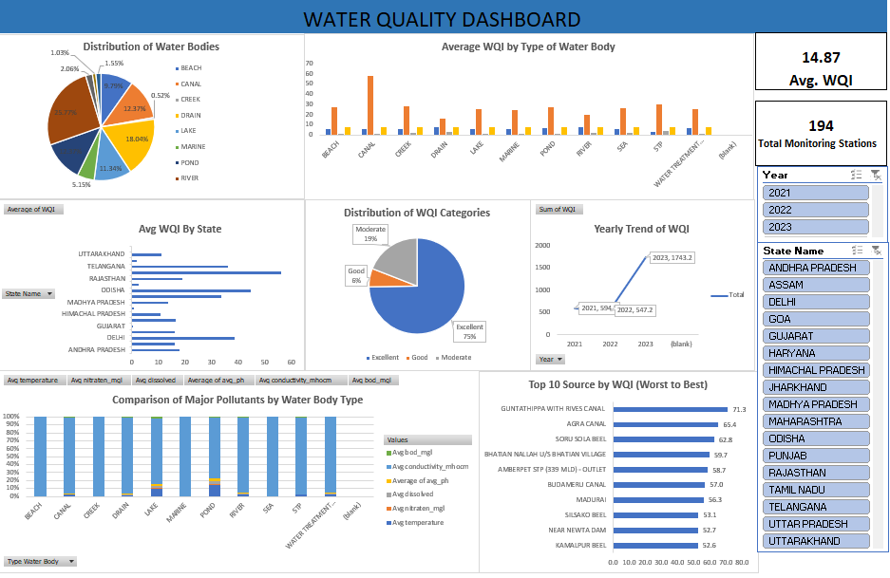

2.3 Environmental Sensor Data Monitoring (SQL, R and Advanced Excel) (Week3)

2.3.1 Introduction
This project focuses on analysing water quality data collected from monitoring stations across India. The raw sensor readings—such as pH, temperature, dissolved oxygen, conductivity, and BOD—are cleaned, pre-processed, and used to calculate the Water Quality Index (WQI). Using Python, R and Excel dashboards, the project identifies pollution levels, detects anomalies, and highlights trends across states and water bodies. The goal is to convert raw environmental data into clear insights that support better water resource management and decision-making using a combination of:
- Python (for data storage, cleaning, and Visualization),
- R Programming (for statistical analysis and visualization), and Ø Excel (for dashboarding and reporting).

2.3.2 Objectives
The primary objective of this research is to analyse the trend and composition of key air pollutants (PM 2.5, PM 10, O3, NO2, etc.) in Delhi over a two-year period (Jan 2021 to Jan 2023). The analysis seeks to identify the most polluted months and verify the hypothesis that air quality significantly deteriorates during the winter months (Oct-Feb) due to high PM 2.5 concentrations.

2.3.3 Methodology
• Clean and preprocess raw water quality sensor data to remove inconsistencies, missing values, and noise.
• Calculate the Water Quality Index (WQI) using key parameters such as pH, DO, BOD, conductivity, and nitrates.
• Detect anomalies in sensor readings that may indicate pollution spikes or data recording errors.
• Analyse trends across states, water bodies, and years to understand spatial and temporal variations in water quality.
• Create visual in Python for easy interpretation of WQI, pollutant levels, and monitoring station performance.
• Generate insights to help support environmental management and policy decisions.

a) Python Phase : Data Cleaning, Preprocessing and Visualization
- Distribution of Water Body Types :
- Rivers are the most frequently monitored/recorded water bodies.
- Ponds are the least common in the dataset.
- Reservoirs and lakes fall in between, with a fairly balanced representation.

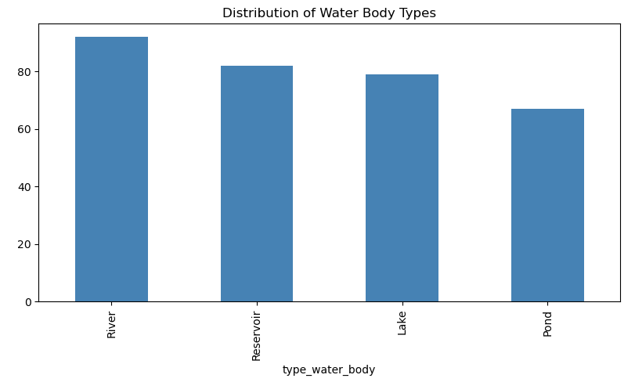

- Average WQI by State
- Tamil Nadu has the highest average Water Quality Index (WQI), indicating relatively better water quality.
- States like Odisha, Maharashtra, Punjab, and Andhra Pradesh also show strong WQI performance.
- Haryana, Uttarakhand, and Uttar Pradesh fall toward the lower end of the WQI range, indicating comparatively poorer water quality.
- Overall, WQI values across states are fairly close, suggesting moderate variation in water quality across the country.

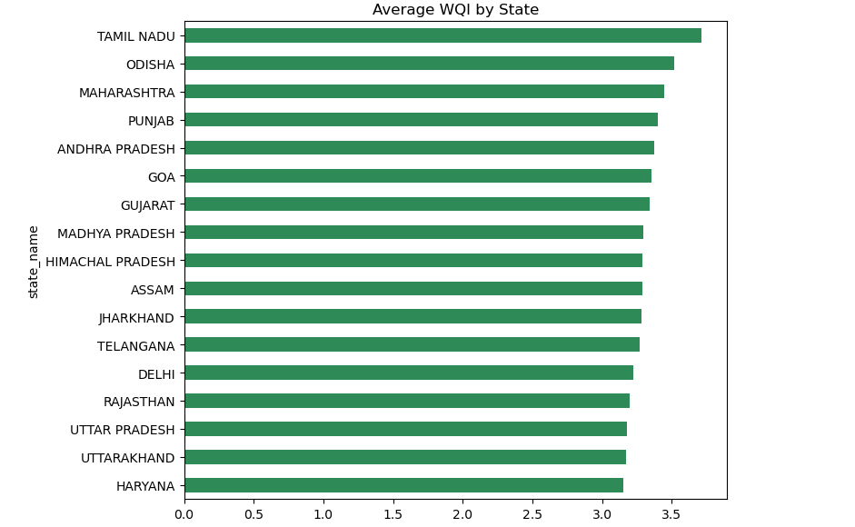

- Average WQI by Water Body Type
- All water body types—Lakes, Ponds, Reservoirs, and Rivers—show almost identical average WQI values.
- This indicates that water quality does not substantially differ by type of water body in this dataset.

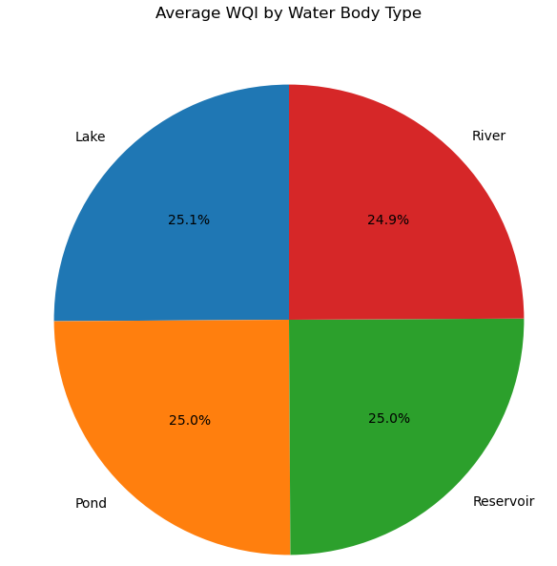
- Distribution of WQI Categories
- The majority of water samples fall into the Excellent Water Quality Index (WQI) category, representing 86.6% of the total distribution.
- A smaller, but significant, portion is categorized as Moderate (12.8%).
- Only a tiny fraction of samples are classified as Poor (0.6%).
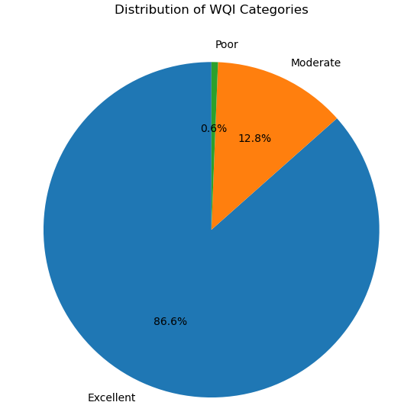
- Yearly Trend of WQI
- The average WQI has fluctuated over the years, showing a general increasing trend from 2000 to 2024.
- The highest average WQI was recorded in 2024 (nearly 3.50).
- The lowest average WQI appears to be around 2017 or 2021 (around 3.23).
- The trend displays significant volatility year-to-year.
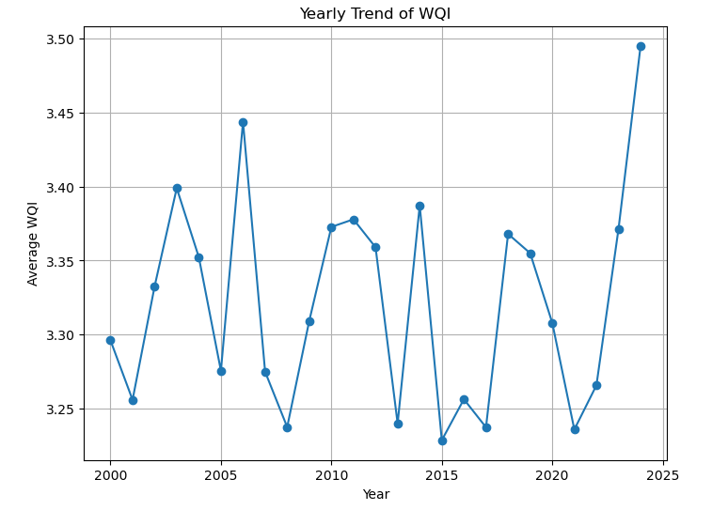
- Comparison of Pollutants Across Water Body Types
- Average Conductivity is the highest value by far across all water body types (Lake, Pond, Reservoir, River), consistently measuring near 190.
- Ponds have the highest average conductivity at 191.06.
- The other pollutants (avg_ph, avg_dissolved, avg_bod) are relatively low and similar across all four water body types.
- avg_ph values are consistently around 7.2.
- avg_dissolved and avg_bod values are all less than 6.1 and 4.0, respectively

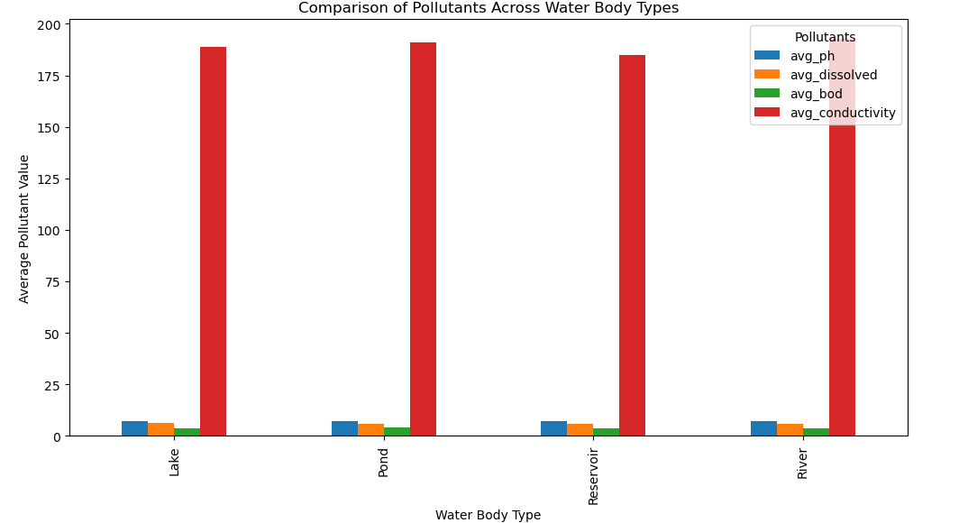

- IQR-Based Anomaly Detection (WQI)
- The median (Q2) WQI value is approximately 3.35 (the line inside the box).
- The Interquartile Range (IQR)—the height of the box—spans from approximately 3.1 (Q1) to 3.5 (Q3).
- The data distribution is relatively symmetric around the median.
- The plot does not show any outliers (data points outside the whiskers), suggesting that based on the IQR method, there are no statistical anomalies in the WQI data set.
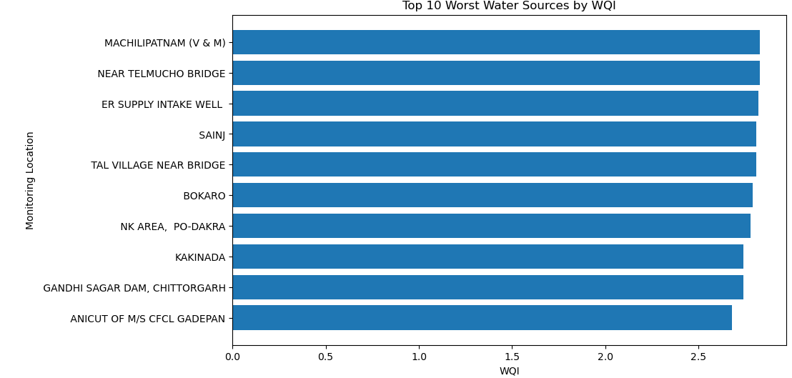
- Top 10 Worst Water Sources by WQI
- All of the top 10 worst water sources have a very similar WQI value, clustered between approximately 2.6 and 2.75.
- ANICUT OF M/S CFCL GADEPAN has the lowest WQI (the worst quality) among this group, around 2.65.
- MACHILIPATNAM (V & M), NEAR TELMUCHO BRIDGE, and ER SUPPLY INTAKE WELL have the highest WQI (still poor quality) among this group, around 2.75.
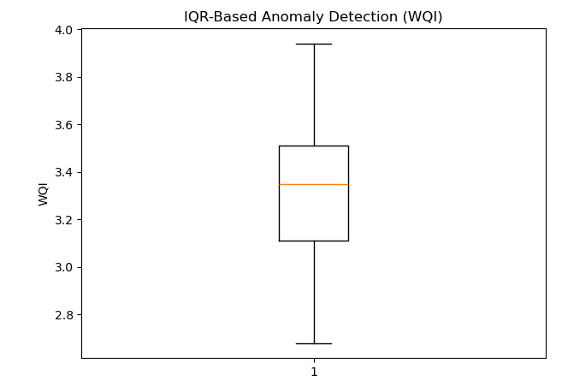

b) R Phase – Statistical Analysis and Visualization
In the second phase, I connected the cleaned SQL dataset to R for exploratory data analysis (EDA), visualization, and predictive modelling.
- Data Connection:
Imported clean dataset table into R using MySQL and converted it into a dataframe for analysis, then Exploratory Data Analysis (EDA) and then used ggplot2 and base R to generate multiple visualizations.
- Visualizations and Insights

- Pie Chart – Average WQI by Water Body→ Water quality is almost uniform across all water body types, with each contributing roughly 25%. This indicates no major difference in average WQI between lakes, ponds, reservoirs, and rivers.
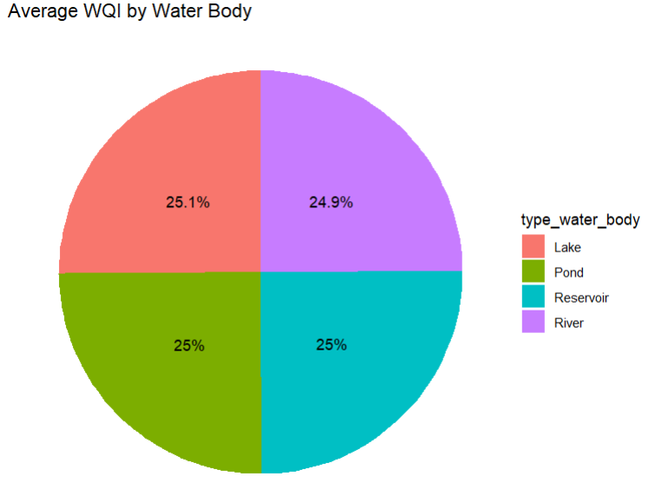

- Bar Chart – Distribution of WQI Categories: Most water sources fall under the “Excellent” WQI category (279), while only 41 fall under “Moderate.” Overall, this shows generally good water quality in the dataset.
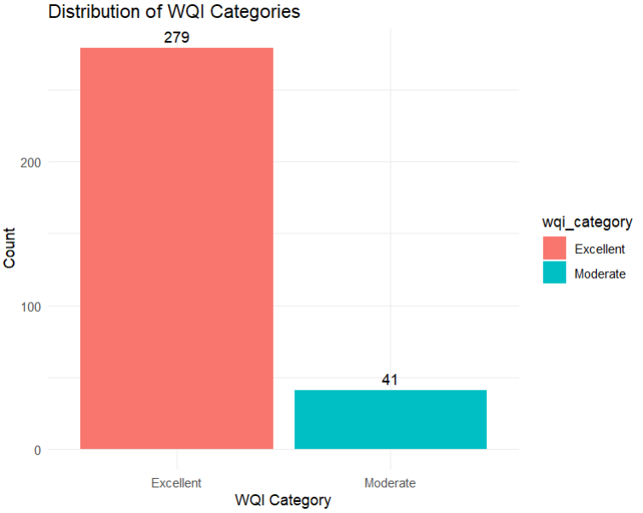
- Bar Chart – Top 10 Worst Water Sources by WQI: The bottom 10 locations have WQI values ranging from 2.68 to 2.8, indicating relatively poorer water quality. Sites like CFCL Gadepan, Kakinada, and Chittorgarh show the lowest scores and may require attention or remediation.

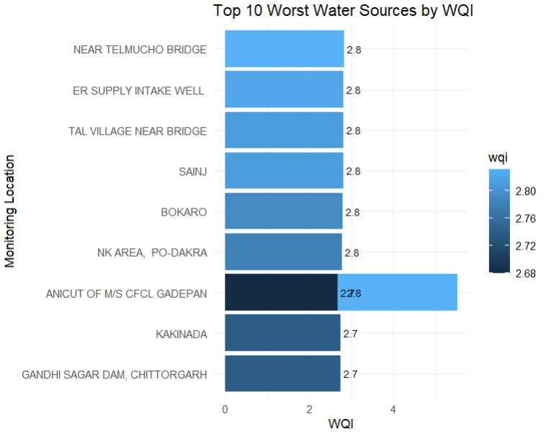

Correlation Heatmap: Dissolved oxygen and temperature show a strong positive correlation with WQI, making them key determinants of water quality. Other parameters (pH, BOD, nitrates, fecal coliform) show weak correlations, indicating minimal influence in this dataset.
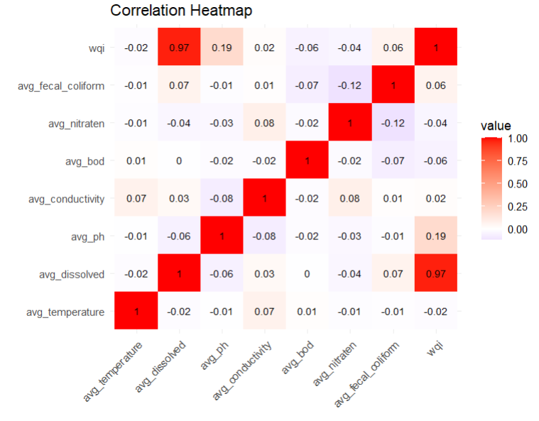
Summary of R Phase: The visual analysis shows that water quality is fairly consistent across different water body types, with each contributing around 25% to the overall WQI distribution. Most locations fall under the “Excellent” category, indicating generally good water conditions, while only a smaller portion is classified as “Moderate.” The list of the top 10 worst-performing locations highlights specific sites with comparatively lower WQI scores that may need targeted monitoring. The correlation heatmap reveals that temperature and dissolved oxygen have the strongest relationships with WQI, while other parameters show weaker associations.

2.3.4 Conclusion
The analysis indicates that most water sources exhibit excellent water quality, with 86.6% of samples in the top WQI category. Yearly trends show a general improvement from 2000 to 2024, though some fluctuations exist. Conductivity is the highest among pollutants, while pH, dissolved oxygen, and BOD remain stable across water body types. No significant anomalies were detected, but a few water sources show poor quality, requiring attention. Water quality is largely similar across lakes, ponds, reservoirs, and rivers, with regional variations showing Tamil Nadu and some southern states performing better than Haryana, Uttarakhand, and Uttar Pradesh. Overall, the findings provide valuable insights for targeted water management and pollution control.

2.4 Fitness Tracker Dashboard- Power BI Dashboard (Week 4)

2.4.1 Introduction

The Fitness Tracker Dashboard project is designed to provide a comprehensive and interactive visualization of personal health and fitness data. By consolidating key metrics such as steps taken, calories burned, heart rate, sleep patterns, and mood trends, the dashboard enables users to monitor their daily activities and overall well-being effectively. The project leverages data analytics and visualization techniques to identify patterns, track progress over time, and offer actionable insights for maintaining a healthy lifestyle. Through intuitive charts and graphs, the dashboard facilitates quick understanding and supports informed decision-making for fitness enthusiasts and health-conscious individuals.

2.4.2 Objectives
The primary objectives of this Power BI project are:
• To monitor and analyse personal health and fitness metrics in a single interactive dashboard.
• To identify trends and patterns in daily activity, sleep, heart rate, and mood over time.
• To provide actionable insights that help users maintain or improve their fitness and well-being.
• To enable data-driven decision-making for personal health management.

2.4.3 Data Overview
The dataset contained around 1000000 rows for a 3year period. The fields included:
- The dataset consists of user fitness and health records collected over a period of time.
- Key attributes include: Date, Time, Steps, Calories Burned, Heart Rate, Sleep Duration, Activity Type, and Mood.
- The data is structured to capture daily and monthly trends for comprehensive analysis.
- Visualization-friendly format allows for aggregation, comparison, and tracking of multiple health parameters simultaneously.

2.4.4 Dashboard Design & Explanation
The Fitness Tracker Dashboard is designed to provide a comprehensive view of user activity, health patterns, and workout intensity over time. The layout follows a top-down analytical structure, beginning with overall KPIs, followed by time-based trend analysis, and ending with deeper breakdowns such as workout types, heart rate patterns, and user activity distribution.
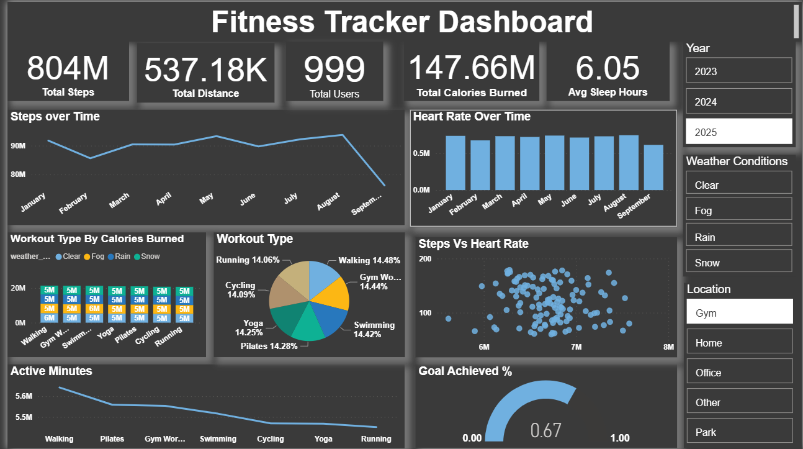

a) Key Performance Indicators (KPIs) : These highlight key performance indicators such as:
- Total Steps
- Total Distance
- Total Users
- Total Calories Burned
- Average Sleep Hours
These are placed at the top for quick assessment of overall performance and user wellness.
b) Steps Over Time (Line Chart)
To analyze periodic activity changes, seasonal patterns, and peak months of movement.

c) Heart Rate Over Time (Column Chart)

To understand workout intensity or stress levels over time.

d) Workout Type by Calories Burned (Bar Chart)

To identify which activities are most effective, and how performance varies by weather.

e) Workout Type Distribution (Pie Chart)
Shows contribution of each workout type—Running, Cycling, Yoga, Swimming, Gym Workouts, Pilates, Walking.

f) Steps vs Heart Rate (Scatter Plot)

To identify intensity patterns—higher steps typically align with elevated heart rate.

g) Active Minutes (Line Chart)
To analyze which activities users spend the most time on.

h) Goal Achieved % (Gauge Chart)

To measure how well users are meeting their targets.

2.4.5 Insights & Findings

The total steps (804M), calories burned (147.66M), and average sleep (6.05 hours) indicate a generally active user base, but sleep duration is slightly below the recommended 7–8 hours.

Steps peak during mid-year (May–August), indicating higher physical activity during warmer months before declining in September.

Average heart rate remains steady across months, suggesting consistent workout intensity and no major fluctuations in user training load.

Running, walking, and gym workouts burn the highest calories overall, showing these are the most physically demanding activities for users.

Workout participation is fairly evenly distributed across activities, indicating users follow a balanced mix of running, walking, swimming, yoga, and gym workouts.

Walking accounts for the highest active minutes, meaning users spend the most time on low-impact endurance exercises.

A positive correlation is visible: higher step counts generally align with higher heart rates, confirming increased activity leads to increased intensity.

The goal achievement rate stands at 67%, showing users meet most, but not all, of their fitness targets.

2.4.6 Conclusion
The dashboard provides a holistic view of user fitness behaviour, combining activity levels, workout types, sleep patterns, and calories burned.

The data suggests:
- Users are moderately active with consistent workout intensity.
- They prefer a balanced mix of activity types.
- Most users meet at least two-thirds of their fitness goals.
- Outdoor conditions and locations influence performance slightly.

The dashboard can be used for:
- Wellness program performance reporting.
- Fitness app analytics.
- Personal or group health monitoring.
- Behavioural insights for user engagement strategies

2.5 Automated Traffic Pattern Analysis Using AI (Week 5)

2.5.1 Introduction
Rapid urbanization has significantly increased vehicular traffic, leading to congestion, delays, and higher emission levels in cities. Traditional traffic management systems rely on static rules and manual monitoring, making them inefficient in handling dynamic traffic conditions.
The project “Automated Traffic Pattern Analysis Using AI” analyses urban traffic data using data analytics and machine learning techniques to identify congestion patterns and generate intelligent recommendations for improving traffic flow. By analysing historical traffic data, the system detects peak hours, congestion hotspots, and traffic inefficiencies, enabling data-driven decision-making for effective traffic management.
This project demonstrates the role of artificial intelligence in supporting smart city initiatives by reducing congestion, improving travel time, and minimizing environmental impact.

2.5.2 Dataset Description
The dataset includes the following key variables:

Time: Time at which traffic data was recorded.

Date: Date of the traffic observation.

Dayoftheweek: Day of the week corresponding to the record.

CarCount: Number of cars observed.

BikeCount: Number of two-wheelers observed.

BusCount: Number of buses observed.

TruckCount: Number of trucks observed.

Total: Total number of vehicles recorded.

Traffic Situation: Overall traffic condition (Low/Normal/High).

WeatherCondition: Weather condition during observation.

JunctionID: Identifier for the traffic junction.

AverageSpeed: Average speed of vehicles (km/h).

VehicleDensity: Measure of traffic density.

CongestionLevel: Level of traffic congestion (Low/Medium/High).

PeakHour: Indicates peak traffic hours (1 = Yes, 0 = No).

2.5.3 Exploratory Data Analysis (EDA)

a) Total Traffic by Day of the Week (Bar Chart)
• Wednesday and Thursday show the highest traffic volume, indicating peak weekday movement.
• Friday has comparatively lower traffic, possibly due to flexible work hours or early departures.
• Weekends (Saturday & Sunday) still show significant traffic, suggesting recreational and non-work travel.

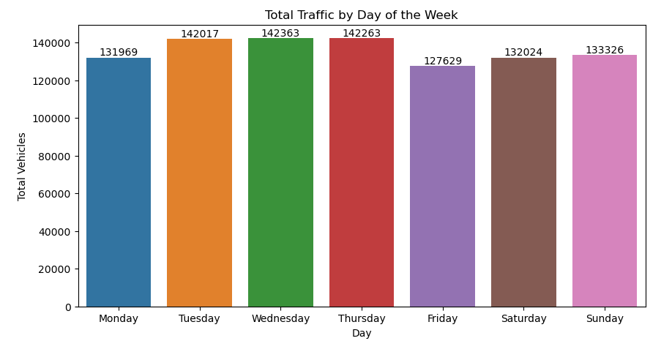

b) Distribution of Traffic Situations (Pie Chart)
• Nearly half of the traffic situations are Normal, indicating stable conditions most of the time.
• High traffic conditions (~33%) are substantial and need attention.
• Low traffic conditions are relatively less frequent.
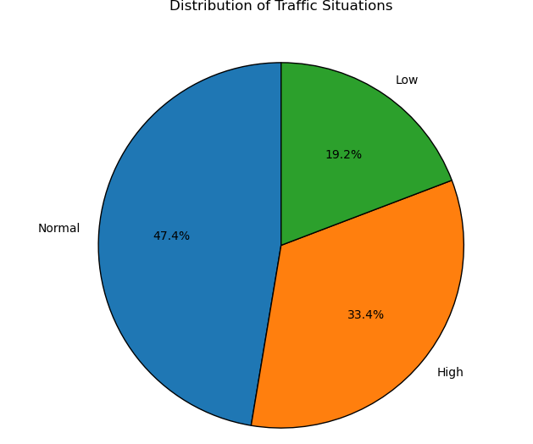

c) Traffic Comparison: Peak vs Non-Peak Hours (Box Plot)
• Peak hours clearly show higher median traffic and greater variability.
• Presence of outliers during peak hours indicates sudden traffic surges.
• Non-peak hours are more stable with lower traffic volumes.

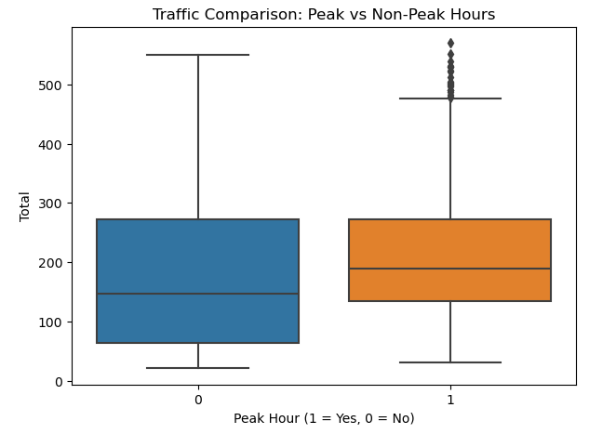

d) Vehicle Type Contribution (Pie Chart)
• Cars dominate traffic (~55%), making them the primary contributor to congestion.
• Bikes form a significant portion, while buses and trucks contribute less in number.
• Despite fewer buses, they carry more passengers per vehicle.
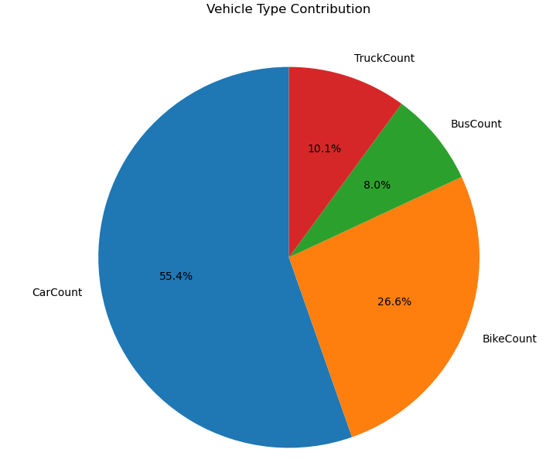

e) Traffic Heatmap: Day vs Weather Condition
• Traffic remains high even during adverse weather like Rainy and Foggy conditions.
• Certain days (e.g., Sunday, Wednesday) show weather-sensitive traffic spikes.
• Weather impacts traffic flow but does not significantly reduce vehicle count.

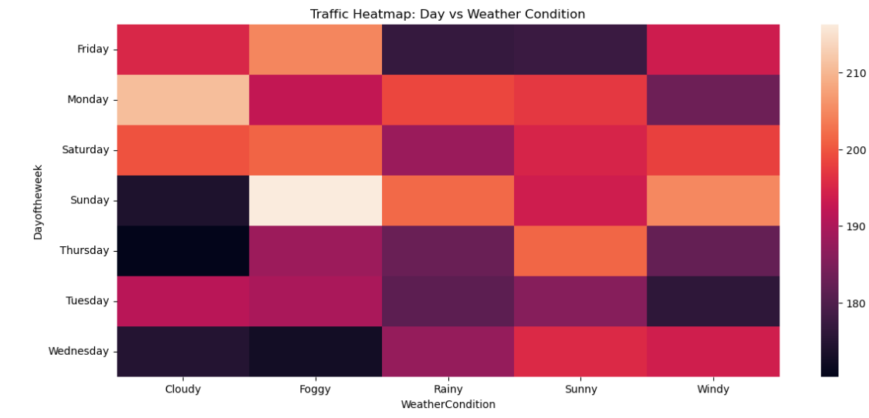

f) Traffic Heatmap: Day vs Weather Condition
• High congestion occurs when both car and bike counts are high, as shown by dense clusters of High traffic points in the upper-right region of the chart.
• Car count is the dominant contributor to congestion, where even moderate bike volumes combined with high car numbers result in Normal to High traffic conditions.
• Low traffic situations are observed when both car and bike counts are low, indicating stable and predictable traffic during off-peak periods.
• Larger bubble sizes align with higher congestion levels, confirming that total vehicle volume is a key indicator of traffic congestion.
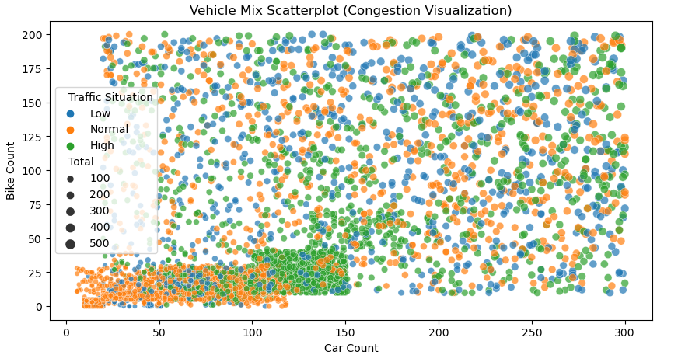

2.5.4 Traffic Congestion with K-Means

a) Elbow Method
• The elbow appears around K = 3, indicating three distinct congestion patterns.
• These clusters represent Low, Medium, and High congestion zones.
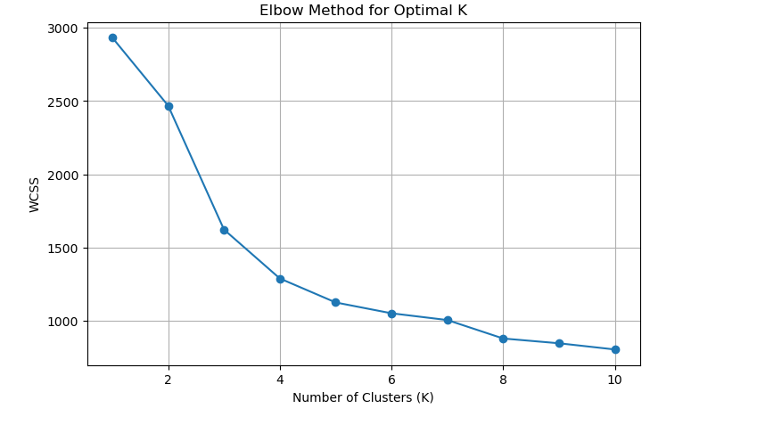

b) Congestion Level (Bar Chart)

Low congestion is the most frequent, indicating smooth traffic flow during most time periods.

High congestion occurs occasionally, likely during peak hours or at major traffic bottlenecks.

Medium congestion has the lowest count, suggesting traffic conditions shift quickly from low to high.

Congestion is unevenly distributed, with traffic stress concentrated in specific times or locations.

Traffic management efforts should focus on high-congestion periods for maximum impact.

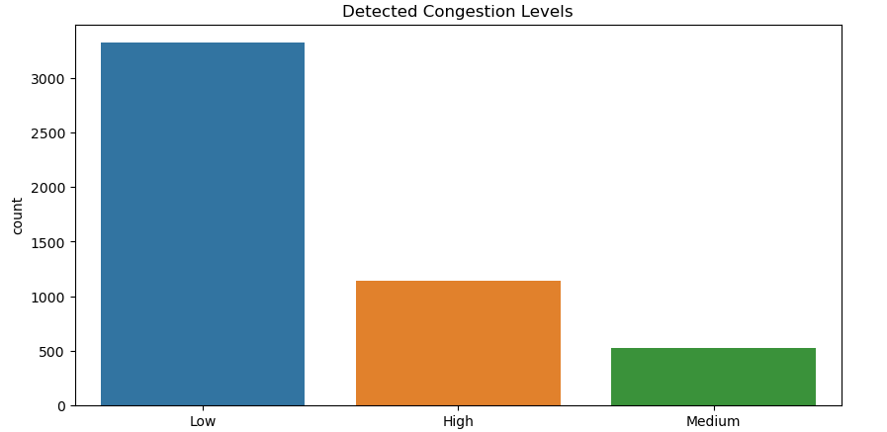

2.5.6 Recommendations
- Traffic Signal Optimization: Implement adaptive signal timing during peak hours and mid-week traffic surges, and increase green light duration for high-density vehicle movements..
- Mobility & Infrastructure: Promote public transport usage and carpooling to reduce private vehicles; introduce dedicated lanes for buses and two-wheelers; restrict movement of heavy vehicles during peak urban hours.
- Weather-Aware Traffic Control: Enable dynamic traffic alerts, rerouting, and enhanced enforcement to ensure road safety during adverse weather conditions.
- AI-Driven Management: Utilize clustering techniques to identify high-congestion zones, deploy predictive congestion alerts based on historical traffic patterns, and transition from static traffic rules to continuous real-time monitoring systems.
- Environmental Impact: Reduce vehicle idle time to lower emissions and fuel consumption, supporting sustainable, eco-friendly, and smart urban transportation systems.

2.5.7 Conclusion
This project successfully segmented mall customers into five distinct groups using K-Means clustering. The Decision Tree model translated these segments into clear business rules. These insights provide the mall with a data-driven foundation for targeted marketing, better resource allocation, and improved customer engagement.

2.6 Poverty and Unemployment Correlation Analysis (Week 6) Major Project
Poverty and unemployment are two of the most critical socio-economic challenges influencing economic stability and social development. High unemployment levels often reduce household income, limit access to education and healthcare, and increase vulnerability to poverty. Conversely, persistent poverty restricts skill development and employment opportunities, creating a cyclical relationship between the two.
In a diverse and populous economy, socio-economic conditions vary significantly across regions due to differences in education levels, labour force participation, economic structure, and sectoral employment. Factors such as literacy rate, school enrollment, dropout rate, gender disparities, and employment distribution across agriculture and services play a vital role in shaping employment outcomes and poverty levels.
This project focuses on analysing the relationship between poverty rates and unemployment rates across states and over time by integrating multiple socio-economic indicators. Using data-driven techniques such as correlation analysis, regression analysis, and interactive visualizations, the study aims to uncover patterns, disparities, and key drivers influencing poverty and unemployment. The insights generated from this analysis can support policymakers and social planners in designing targeted welfare programs, education initiatives, and employment strategies.
The project was done collaboratively in a team of two members:
- Prakhar Khandelwal – Data collection, correlation analysis, regression analysis, statistical interpretation, and report writing
- Prachi Saini – Data cleaning, preprocessing, visualization development using Power BI, presentation (PPT) design, and storytelling.
- Joint Responsibility -- Data preprocessing validation, dashboard design refinement, KPI selection, and insight validation.

2.6.1 Project Objective
• Examine the relationship between poverty and unemployment across states and time.
• Evaluate the influence of education and literacy on employment outcomes.
• Analyse labour force participation and demographic unemployment trends.
• Identify sectoral and regional drivers of persistent poverty.
• Deliver data-driven insights through interactive dashboards for policymakers.

2.6.2 Nature of Dataset
The dataset used for this analysis included:
700 rows and 12+ columns with data such as:
- State | Name of the state or region.

- Year | Year to which the data corresponds.

- Population | Total population of the state in the given year.

- GDP per Capita (INR) | Average economic output per person, measured in Indian Rupees.

- Poverty Rate (%) | Percentage of the population living below the poverty line.

- Literacy Rate (%) | Percentage of the population aged 7 years and above who can read and write.

- Male Literacy Rate (%) | Literacy rate among the male population.

- Female Literacy Rate (%) | Literacy rate among the female population.

- School Enrollment Rate (%) | Percentage of eligible population enrolled in schools.

- Dropout Rate (%) | Percentage of students who discontinue schooling before completion.

- Labour Force Participation Rate (%) | Percentage of the working-age population that is either employed or actively seeking employment.

- Unemployment Rate (%) | Percentage of the labour force that is unemployed.

- Youth Unemployment Rate (%) | Unemployment rate among the youth population.

- Female Unemployment Rate (%) | Unemployment rate among the female labour force.

- Employment in Agriculture (%) | Percentage of employed population working in the agricultural sector.

- Employment in Services (%) | Percentage of employed population working in the services sector.

Work Division and Detailed Contribution
- Prakhar Khandelwal
Contribution Details:
- Collected and integrated socio-economic data from multiple secondary sources including census data, labour statistics, and economic indicators.
- Conducted correlation analysis to examine the relationship between poverty rate and unemployment rate across states and years.
- Performed regression analysis to identify key predictors of poverty, including unemployment rate, literacy rate, GDP per capita, and labour force participation rate.
- Identified states exhibiting strong positive correlation between poverty and unemployment, highlighting high-risk regions.
- Analysed the impact of education indicators such as literacy rate, school enrollment, and dropout rate on unemployment and poverty levels.
- Documented statistical findings and interpretations in the project report.

Insights:
• States with higher unemployment rates generally exhibited higher poverty rates, indicating a strong positive correlation.
• Higher literacy and school enrollment rates were associated with lower poverty and unemployment levels.
• GDP per capita showed a negative relationship with poverty, suggesting better economic output reduces poverty incidence.
• Youth and female unemployment emerged as critical contributors to overall unemployment trends.
Conclusion:
The statistical analysis confirmed a significant relationship between unemployment and poverty, influenced by education and economic structure. The findings provide a strong analytical foundation for targeted policy interventions aimed at employment generation and educational development.

- Prachi Saini
Her analysis included:
• Cleaned and pre-processed the merged dataset by handling missing values, correcting inconsistencies, and standardizing units (percentages and population metrics).
• Validated data quality through exploratory data analysis and summary statistics.
• Designed and developed an interactive Power BI dashboard showcasing key KPIs and socio-economic indicators.
• Created insightful visualizations including trend charts, bar charts, scatter plots, pie charts, and correlation matrices.
• Developed a structured PPT presentation translating analytical findings into clear visual narratives for stakeholders.
• Assisted in selecting KPIs and refining dashboard layout to ensure clarity and usability.
Insights:
- Visualization revealed persistent poverty and unemployment patterns in specific states over multiple years.
- Education-related visuals highlighted the inverse relationship between literacy rates and dropout rates.
- Sectoral employment charts showed that agriculture-dominated states tend to have higher poverty rates compared to service-oriented states.
- Gender-based unemployment charts exposed higher vulnerability among youth and female populations.
Conclusion:
The dashboard and visual analytics enabled intuitive understanding of complex socio-economic relationships. The visual storytelling effectively translated data into actionable insights, supporting informed decision-making by policymakers and planners.
3. Joint Contribution – Preprocessing & Dashboard Development
Both members collaborated closely to:
- Validate preprocessing steps to ensure analytical accuracy.
- Align statistical findings with dashboard visualizations.
- Design KPIs reflecting core project objectives.
- Review and refine dashboards to ensure consistency between insights and visuals.

Visualization & Insights of Project:
1. Top 10 States by Average Population (Bar Chart)
Insights:
- Chhattisgarh has the highest average population among the listed states.
- Haryana and Telangana closely follow, indicating relatively higher population concentration.
- Bihar, Himachal Pradesh, and Goa are on the lower end among the top 10.
- The population values are fairly close (roughly between 1.6–1.9 million), suggesting no extreme population disparity among these states.
- The distribution indicates moderate population balance, rather than dominance by one state.
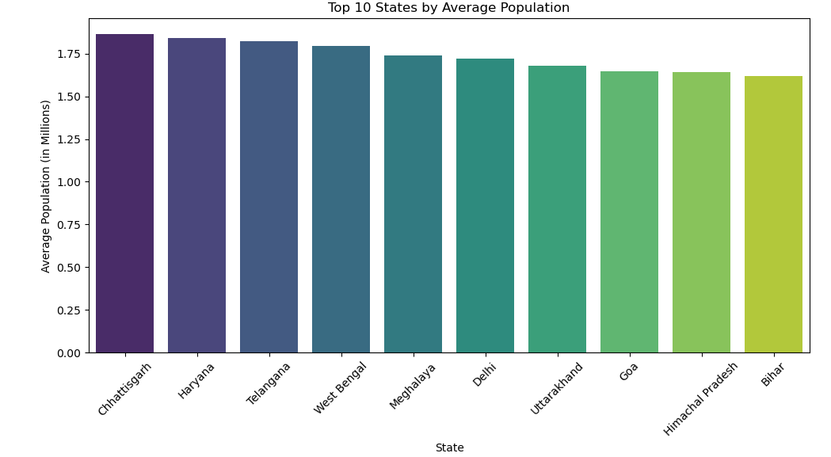

2. Poverty Trend Over Years (2018–2023)
Insights:
- Poverty rate increased from 2018 to 2020, peaking around 2020.
- A sharp decline in 2021, indicating improvement in poverty conditions.
- Slight increase in 2022, followed by another rise in 2023.
- Overall, poverty levels show fluctuation rather than a steady decline.
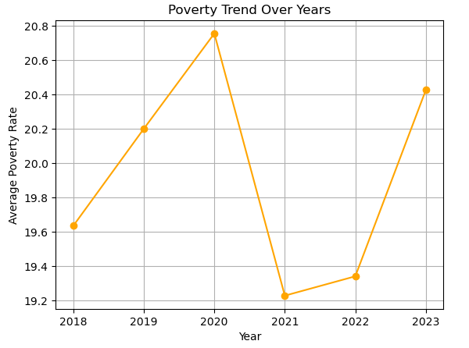

3. Gender Literacy Distribution
Insights:
- Male literacy rate: ~51.8%
- Female literacy rate: ~48.2%
- The gender gap is present but relatively narrow (~3.6%).
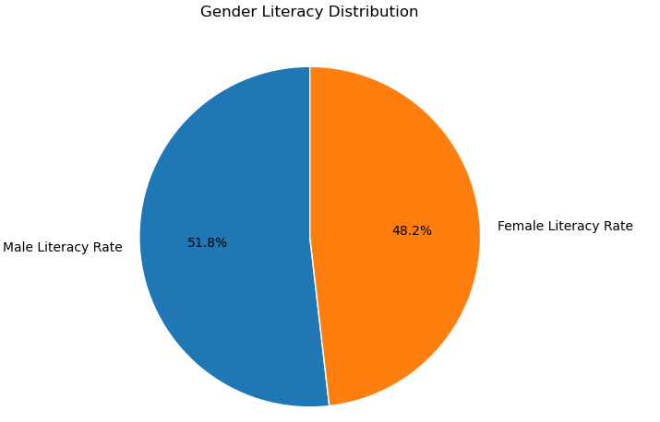

4. Top 10 States by Poverty Rate (Bar Chart)
Insights
- Rajasthan emerges as the state with the highest average poverty rate, followed by Puducherry and Sikkim.
- The presence of both large and smaller states in the top 10 indicates that poverty is not limited to population size, but influenced by regional economic structure and employment opportunities.
- States like Kerala and Maharashtra appearing in the list suggest internal regional inequalities despite relatively stronger economic indicators.

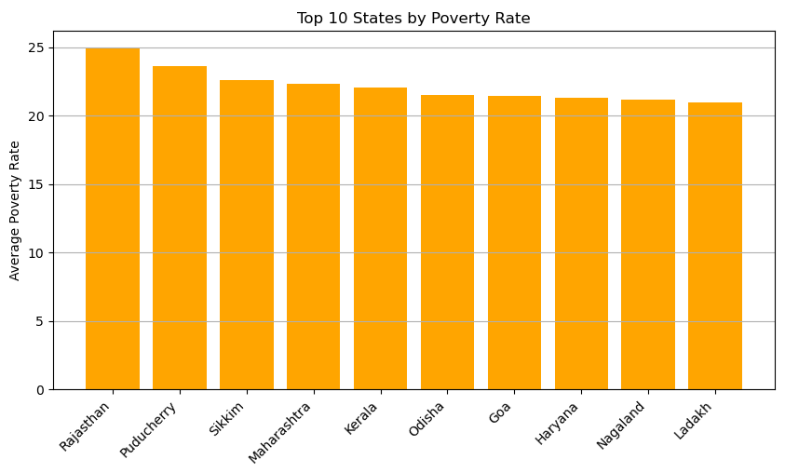

5. Poverty Rate Distribution by State (Box Plot)
Insights
- Significant variation in poverty rates is observed across states, as indicated by wide interquartile ranges.
- Several states show high variability and outliers, reflecting uneven socio-economic development within states.
- States with narrower boxes indicate more consistent poverty levels, while wider boxes suggest fluctuating poverty trends over years.
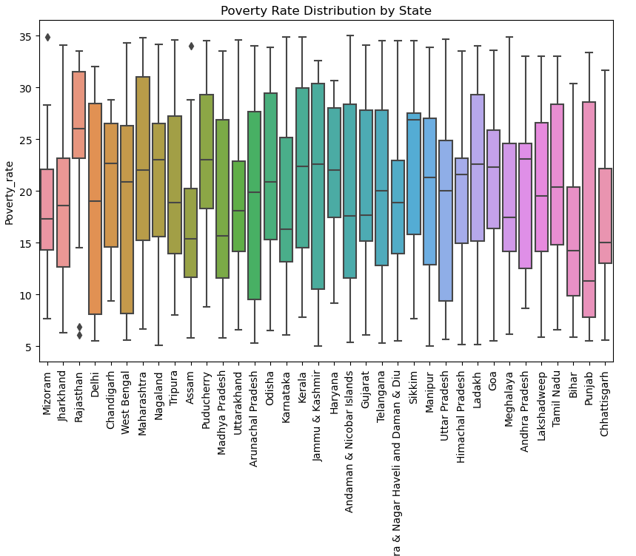

6. GDP per Capita vs Poverty Rate (Bubble Chart)
Insights
- A general inverse relationship is visible: states with higher GDP per capita tend to have lower poverty rates.
- However, dispersion of points shows that economic output alone does not eliminate poverty, indicating the role of employment quality and education.
- Bubble sizes (population) reveal that high-population states with moderate GDP per capita still experience notable poverty levels.
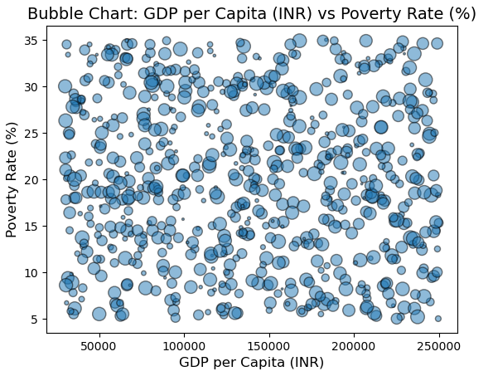
7. Youth vs Female Unemployment (Pie Chart)
Insights
- Youth unemployment contributes a larger share compared to female unemployment.
- This indicates a structural challenge in youth employment, especially in education-to-employment transition phases.
- Female unemployment still represents a significant portion, highlighting gender-based labour market barriers.
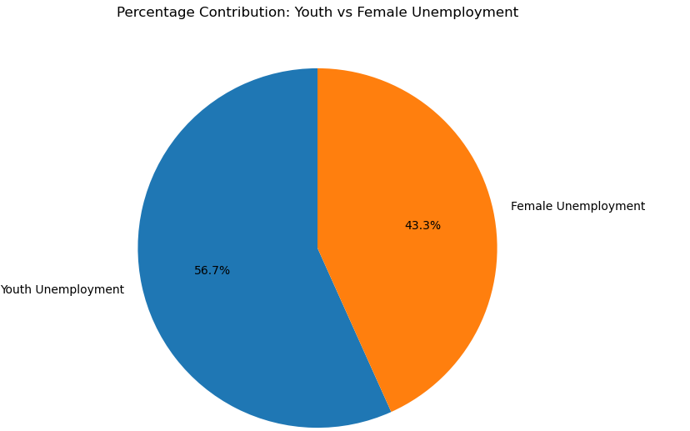

8. Poverty vs Unemployment Trend Over Time (Line Chart)
Insights
- Poverty and unemployment exhibit similar directional movements, suggesting a strong relationship.
- A noticeable dip around 2021 may reflect temporary policy interventions or economic recovery effects.
- The rise again in later years indicates persistent structural challenges.
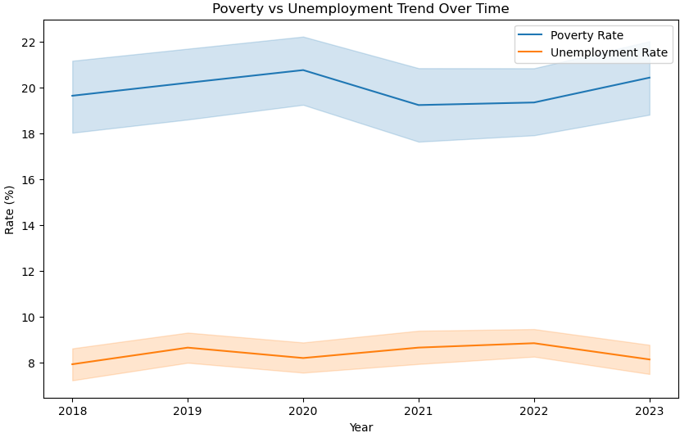
9. Scatter Plots with Trendlines
Insights
- Poverty vs Unemployment: A positive trendline confirms that higher unemployment is associated with higher poverty.
- Poverty vs Literacy: A negative relationship indicates that higher literacy correlates with lower poverty levels.
- Unemployment vs Literacy: Higher literacy generally aligns with lower unemployment rates, though variability exists.

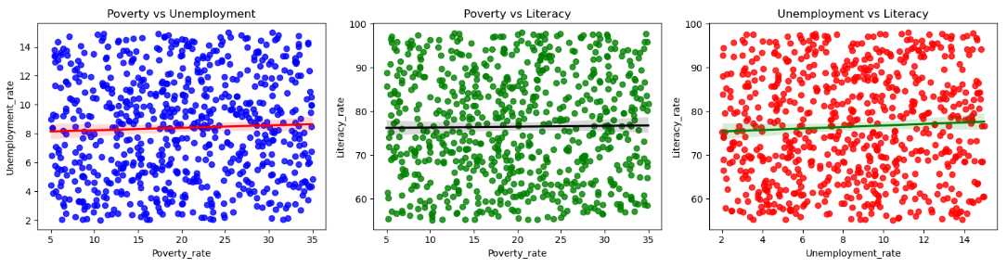

10. Correlation Heatmap
Insights
- Poverty rate shows a positive correlation with unemployment indicators.
- Negative correlation between GDP per capita and poverty supports economic theory.
- Literacy rate is negatively correlated with both poverty and unemployment.
- Dropout rate shows a positive association with poverty, highlighting education discontinuity as a risk factor.

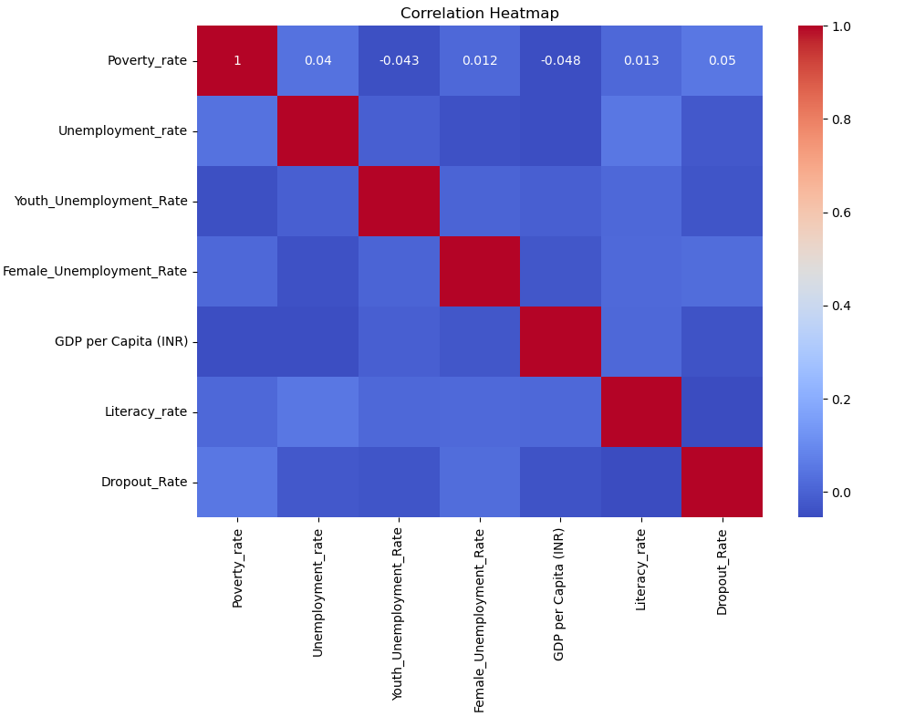

Dashboard Insights:
1. Overall Socio-Economic Snapshot (KPI Cards)
- The average GDP per capita (₹137.61K) indicates moderate economic output across states, but it is not sufficient to uniformly reduce poverty.
- Despite a relatively high average literacy rate (76.5%), the average poverty rate remains high at 19.92%, suggesting that literacy alone does not guarantee economic security.
- The average unemployment rate (8.39%) and youth unemployment rate (14.89%) highlight employment challenges, particularly among the younger population.

2. Poverty vs Unemployment (Scatter Plot)
- The scatter plot shows a positive relationship between poverty and unemployment.
- States with higher unemployment rates generally exhibit higher poverty levels.
- Data points are clustered, indicating that this relationship is consistent across multiple regions.

3. GDP vs Poverty (Bubble Chart)
- States with higher GDP per capita tend to have lower poverty rates, showing an inverse relationship.
- However, some states with moderate GDP still experience high poverty, indicating unequal wealth distribution.
- Larger bubbles (higher population) with high poverty signal high-impact regions where interventions can benefit more people.

4. Poverty Rate Over Year (Bar Chart)
- Poverty rates show a gradual decline over time, but the reduction is slow.
- Certain states continue to exhibit persistently high poverty, indicating structural challenges.
- The trend suggests partial effectiveness of welfare measures, but not enough for long-term elimination.

5. School Enrollment vs Dropout Rate (Dual-Axis Chart)
- School enrollment remains consistently high across years.
- Dropout rates fluctuate and rise in certain periods despite stable enrollment.
- This gap highlights issues related to education continuity and quality rather than access.

6. Unemployment Rate by Year (Line Chart)
- Unemployment increases sharply around 2021, likely reflecting economic disruptions.
- A gradual decline afterward indicates recovery, but rates remain above pre-disruption levels.
- This trend aligns closely with changes observed in poverty rates.

7. Employment Share by Sector (Pie Chart)
- Employment is almost evenly split between agriculture (39.27%) and services (36.79%).
- Heavy reliance on agriculture suggests income instability and vulnerability, especially in rural regions.
- Service-sector employment, which is generally more stable, still has limited penetration.
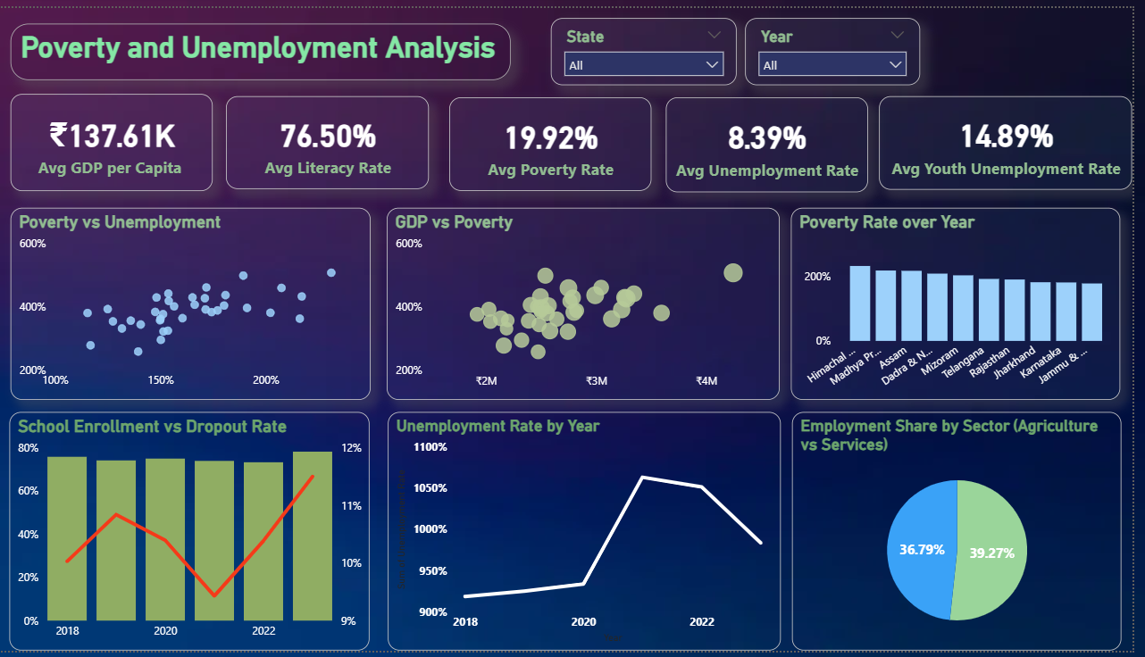

Conclusion:
The dashboard highlights a strong interconnection between unemployment and poverty, moderated by education, economic output, and employment structure. While literacy and GDP have improved, insufficient employment opportunities—especially for youth—continue to sustain poverty levels. Targeted employment generation, education retention, and sectoral diversification are essential for sustainable socio-economic development.

Recommendation:
Based on the dashboard insights, poverty and unemployment are strongly interconnected and influenced by education levels, labour market participation, and sectoral employment structure. To address these challenges, policies should prioritize employment generation—especially for youth and women—along with skill development programs aligned to market needs. Reducing school dropout rates, promoting inclusive economic growth, and encouraging a shift from agriculture to higher-productivity service sectors are essential. Targeted, state-specific interventions supported by continuous data-driven monitoring can help design effective social welfare and employment policies and ensure sustainable poverty reduction.

CHAPTER 4: RESULTS AND DISCUSSIONS
This chapter presents the insights derived from all six projects, highlighting outcomes and skills developed.
4.1 Insights from Weekly Projects

Project | Key Findings & Insights | Tools Used
Week 1 - Air Quality Dashboard - Delhi Analysis Report | PM2.5 is the dominant pollutant, contributing nearly 79% of total pollution, with PM10 playing a much smaller role. Pollution levels show a strong seasonal pattern, peaking during winter months (November–December) and remaining lowest during summer and monsoon periods. The most severe pollution occurs in winter, with a notable deterioration observed in late 2022. Daily trends indicate elevated pollution during early morning hours and a sharp evening peak between 5–7 PM, driven mainly by traffic and atmospheric conditions. PM10 remains consistently higher than PM2.5, while NO₂ follows a similar evening pattern but at much lower concentrations. | MS Excel
Week 2 - Environmental Sensor Data Monitoring (Water Quality) | Water quality monitoring is mainly concentrated in rivers and lakes, highlighting their environmental importance, while creeks and drains receive limited coverage. Rivers and ponds generally show better water quality, whereas drains and creeks exhibit higher pollution levels. States such as Uttarakhand, Rajasthan, and Telangana record higher WQI, while urban and industrial regions like Delhi and Gujarat require focused intervention. Most water bodies fall under the excellent category, though a portion remains moderate and needs improvement. A sharp rise in WQI in 2023 suggests improved monitoring or effective management measures. Pollutant levels vary by water body type, with drains showing higher contamination. While top-performing sources display relatively good WQI, consistent monitoring is necessary. Overall, widespread monitoring exists, but water quality outcomes remain mixed. | MS Excel, SQL
Week 3 - Environmental Sensor Data Monitoring | The visual analysis shows that water quality is fairly consistent across different water body types, with each contributing around 25% to the overall WQI distribution. Most locations fall under the “Excellent” category, indicating generally good water conditions, while only a smaller portion is classified as “Moderate.” The list of the top 10 worst-performing locations highlights specific sites with comparatively lower WQI scores that may need targeted monitoring. The correlation heatmap reveals that temperature and dissolved oxygen have the strongest relationships with WQI, while other parameters show weaker associations. | SQL, R, MS Excel & Python
Week 4 - Fitness Tracker Dashboard | The data indicates an active user base with high step counts and calorie burn, though average sleep remains slightly below recommended levels. Physical activity peaks during mid-year, while heart rate stays consistent, reflecting stable workout intensity. Running, walking, and gym workouts contribute most to calorie burn, with walking dominating active minutes. Users maintain a balanced mix of activities, show a positive link between steps and heart rate, and achieve fitness goals at a moderate success rate of 67%. | MS Excel & Power BI
Week 5 - Automated Traffic Pattern Analysis Using AI | Traffic volume is highest on midweek days, especially Wednesday and Thursday, while weekends still experience considerable movement due to non-work travel. Most traffic conditions remain normal, though a significant share of high congestion highlights the need for better traffic management. Peak hours show higher and more variable traffic compared to stable non-peak periods. Cars are the dominant contributors to congestion, followed by bikes, with total vehicle volume strongly linked to traffic intensity. Weather conditions influence traffic flow but do not drastically reduce vehicle counts. Clustering analysis identifies three clear congestion levels, with low congestion being most common and high congestion concentrated during specific peak times, indicating where targeted interventions can be most effective. | MS Excel, Python
Week 6 - Poverty and Unemployment Correlation Analysis | The dashboard highlights a mixed socio-economic scenario where moderate GDP per capita and high literacy levels have not translated into low poverty, largely due to persistent unemployment, especially among youth. A clear positive relationship exists between unemployment and poverty, while higher GDP per capita generally corresponds to lower poverty, though population-heavy states still face significant challenges. Poverty levels show only a slow decline over time, indicating limited long-term impact of welfare measures. Despite high school enrollment, fluctuating dropout rates point to issues in education continuity. Employment trends reveal post-2021 recovery, yet joblessness remains elevated, and the near-equal reliance on agriculture and services underscores the need for stable, higher-productivity employment opportunities to reduce poverty sustainably. | MS Excel, Python & Power BI

4.2 Skills Gained
Tools/Skill Category | Description | Techniques
Data Handling | Learned data import, merge, and preprocessing for analysis. | Python, Excel, SQL
Statistical Analysis | Understood correlation, regression, and descriptive analysis. | R, Python
Visualization | Created meaningful dashboards and visuals for decision-making. | Power BI, Excel
Analytical Thinking | Interpreted trends and relationships from raw data. | All Projects
Communication Skills | Presented weekly insights and prepared, project reports. | MS Word & Power point
Teamwork and Coordination | Collaborated with team members on tasks Slack, and final integration. | Google Meet

CHAPTER 5: CONCLUSION

5.1 Overall Learning Outcomes
The internship at Global Next Consulting India Pvt. Ltd. provided practical exposure to the full cycle of data analytics — from collection and cleaning to visualization and reporting.
Through six structured projects, I gained experience with Python, R, SQL, Excel, and Power BI, enabling me to analyse, visualize, and interpret complex datasets.
Each project focused on a unique real-world domain — public health, environment, agriculture, e-commerce, HR, and employment analysis — strengthening domain understanding and adaptability.
The Major Project on Poverty and Unemployment Correlation Analysis integrated all previous learnings into a comprehensive data-driven business insight model.
The internship enhanced both technical and professional skills, including analytical reasoning, teamwork, problem-solving, and effective communication.

5.2 Applications of Work
The methodologies and tools learned during this internship can be applied in:
- Business Analytics: Developing dashboards to monitor key performance indicators.
- Human Resources: Predicting skill demands and identifying hiring gaps.
- Public Policy: Analyzing health and environmental datasets for government insights.
- Agriculture & Sales Forecasting: Understanding production trends and improving business decisions.
- Research & Academia: Applying data-driven decision-making techniques for real-world problem solving.

Internship Certificate

